**TCS Solutions**

**Question – 1:**

An automobile company manufactures both a two wheeler (TW) and a four wheeler (FW). A company manager wants to make the production of both types of vehicle according to the given data below:

• 1st data, Total number of vehicle (two-wheeler + four-wheeler)=v

• 2nd data, Total number of wheels = W

The task is to find how many two-wheelers as well as four-wheelers need to manufacture as per the given data.

**Example :**

**Input :**

200 -> Value of V

540 -> Value of W

**Output :**

TW =130 FW=70

**Explanation:**

130+70 = 200 vehicles

(70*4)+(130*2)= 540 wheels

**Constraints :**

• 2<=W

• W%2=0

• V<W

Print “INVALID INPUT” , if inputs did not meet the constraints.

**Program :**

v = int(input("Enter No.Of Vechicles : "))

w = int(input("Enter No.Of Wheels : "))

if 2 <= w and w%2 == 0 and v < w :

''' ...... '''

fw = (w//2) - v

tw = v - fw

print("TW = ", tw, "FW = ", fw)

else:

print("INVALID INPUT")

**Output :**

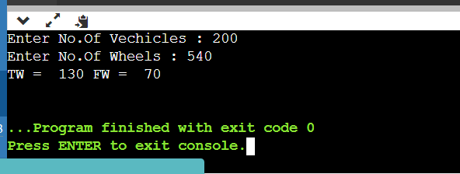

**Question – 2:**

Given a string S(input consisting) of ‘*’ and ‘#’. The length of the string is variable. The task is to find the minimum number of ‘*’ or ‘#’ to make it a valid string. The string is considered valid if the number of ‘*’ and ‘#’ are equal. The ‘*’ and ‘#’ can be at any position in the string.

**Note :** The output will be a positive or negative integer based on number of ‘*’ and ‘#’ in the input string.

• (*>#): positive integer

• (#>*): negative integer

• (#=*): 0

**Example 1:**

**Input 1:**

• ###*** -> Value of S

**Output :**

• 0 → number of * and # are equal

**Program :**

s = input("Enter Your String : ")

star = s.count("*")

ash = s.count("#")

if star > ash :

print("Minimum Number : ", (star - ash))

elif ash > star :

print("Minimum Number : ", (star - ash))

elif star == ash:

print("They are equal : ", 0)

**Output :**

